CT: Good datasets

ASK ABOUT ONEDRIVE AVAILABLE SPACE FOR STUDENTS

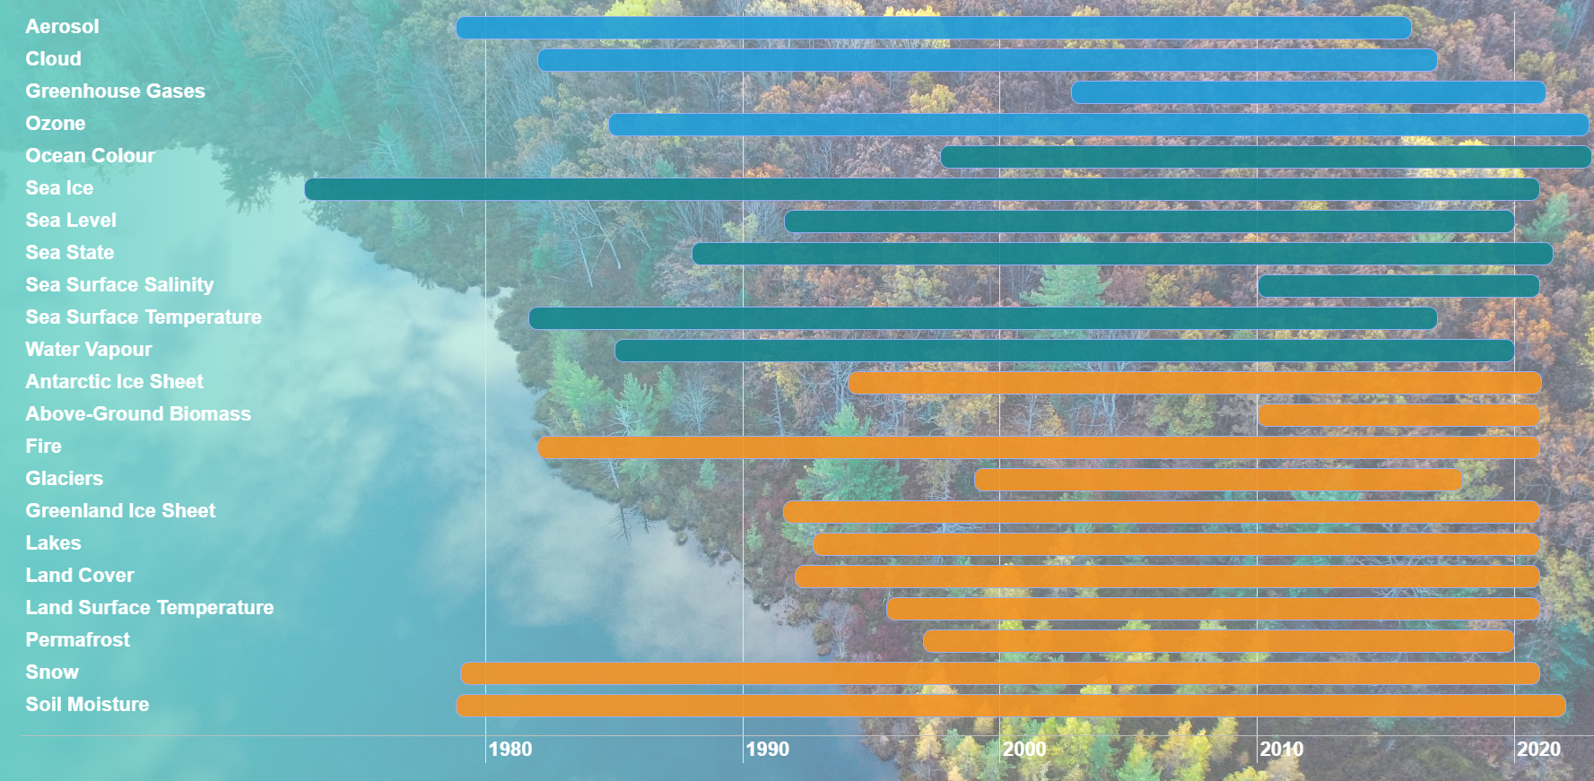

Aerosol:

Cloud:

Greenhouse gases:

Ozone: Merged Level 3 Limb Ozone Monthly Zonal Mean (MZM) Profiles, Version 2

2 years, monthly

3.1 MB

Indiv ~KB

Ocean colour:

Sea ice: Sea Ice Concentration Climate Data Record from the AMSR-E and AMSR-2 instruments at 25km grid spacing, version 2.1

15 years, daily

47.2 GB

Indiv 9.4 MB

Sea level: Time series of gridded Sea Level Anomalies (SLA), Version 2.0

22 years, monthly

1.2 GB

Indiv 4.0 MB

Sea state:

Sea surface salinity:

Sea surface temperature:

Water vapour:

Antarctic ice sheet:

Above-ground biomass:

Fire:

Glaciers:

Greenland ice sheet:

Lakes:

Land cover:

Land surface temperature:

Permafrost:

Snow:

Soil moisture: